Members

***DASU MOSES-----------------------------------------------------8791421***

***CLIFFORD OSEI-------------------------------------------------8796321***

***FORDJOUR ANDY STEVE-------------------------------------8792121***

HOW THE INTERNET WORKS

***Problem statement***

In today's digitally connected world, the internet serves as the backbone of global communication, commerce, and information dissemination. However, despite its widespread use, there exists a significant gap in understanding the underlying mechanisms that enable the internet to function. This lack of awareness hinders individuals from fully comprehending how their online interactions occur, potentially leaving them vulnerable to security risks and inhibiting their ability to make informed decisions in the digital realm.

The problem at hand can be summarized as follows:

* **Pervasive Usage with Limited Understanding:** The internet has become an integral part of daily life, yet many individuals utilize its services without a clear grasp of the processes that facilitate data transmission, content delivery, and communication.
* **Security and Privacy Implications:** Ignorance about how data travels through the internet can lead to poor security practices. Users might not recognize potential threats or understand how to safeguard their personal and sensitive information effectively.
* **Dependency on Online Platforms:** As reliance on online platforms increases, individuals risk becoming passive consumers rather than informed participants. This knowledge gap prevents them from leveraging the full potential of the internet for personal, educational, and professional purposes.
* **Digital Empowerment:** Understanding how the internet works is a crucial aspect of digital literacy. Without this foundational knowledge, individuals are at a disadvantage in an increasingly technology-driven society.
* **Barriers to Learning:** The technical jargon and complexity surrounding internet architecture and protocols can intimidate learners, making it challenging for them to access and internalize the information.

***Aim of the Project:***

The aim of this project is to bridge the chasm of understanding that exists between the ubiquitous presence of the internet in our lives and the limited comprehension of its intricate mechanisms. By distilling the complexities of internet functionality into accessible and comprehensible explanations, the project seeks to empower individuals with a fundamental understanding of how the internet works. This aim is anchored in several core principles:

* **Empowering Digital Citizenship:** The project's primary objective is to equip individuals with the knowledge required to be active and responsible digital citizens. In the digital age, being a consumer of online content is no longer sufficient; individuals must also be informed participants who can navigate the digital landscape with confidence, make informed decisions, and protect their digital identities.
* **Fostering Informed Decision-Making:** The project aspires to enable users to make informed decisions in their online interactions. By comprehending the underlying processes of data transmission, content delivery, and communication protocols, individuals will be better equipped to discern credible sources, evaluate the security of online platforms, and protect their personal information.
* **Unveiling Opportunities for Innovation:** Central to the project's aim is the belief that understanding the internet's core operations will unleash a world of innovative possibilities. Armed with knowledge about the architecture, protocols, and technologies that constitute the internet, individuals will be better positioned to explore new avenues, develop innovative solutions, and contribute to the technological advancement of society.
* **Bridging the Digital Divide:** The project aims to contribute to narrowing the digital divide by ensuring that individuals across various backgrounds have access to foundational knowledge about the internet. Digital literacy should not be a privilege; it should be a democratized asset that empowers all members of society, irrespective of their technological backgrounds.
* **Enhancing Lifelong Learning:** The project aligns with the philosophy of lifelong learning. By offering clear explanations, relatable examples, and visual aids, the project not only imparts knowledge but also instills a curiosity that encourages continuous exploration and understanding of evolving digital technologies.

***Specific Objectives of the Project:***

* To explain the concept of packet switching and its role in data transmission over the internet.
* To explore the architecture of the internet, including the roles of ISPs, routers, and data centers.
* To illustrate the Domain Name System (DNS) and its importance in translating domain names to IP addresses.
* To clarify the concept of protocols and their role in facilitating communication between devices on the internet.
* To provide insights into the layers of the OSI model and how they contribute to the internet's functionality.

***Justification of the Project***

Understanding how the internet works is crucial in today's interconnected world. It enables individuals to use the internet more effectively, make informed choices about online security, and fosters a deeper appreciation for the technology that has become integral to daily life.

***Motivation for Undertaking Project***

The motivation for undertaking this project stems from the realization that many people use the internet without truly understanding the mechanisms behind it. Empowering individuals with this knowledge can lead to a more meaningful and secure online experience

**Scope of the Project**

In this section the project will focus on explaining the fundamental concepts of the internet's infrastructure, data transmission, protocols, and network layers and other factors contributing to **how the internet works**. It will not delve deeply into advanced topics such as complex routing algorithms or intricate security protocols.

This section will serve as the main body of the project that broadly and vastly delve deeper into explaining all factors that plays a role into how the internet really works, below are the explicit and broad explanation of the factors contributing to **how the internet works**:

***Introduction to the internet***

**Origins**: The origins of the **Internet** date back to the development of **packet switching** and research commissioned by **the United States Department** **of** **Defense in the late 1960s** to enable time-sharing between computers. The primary precursor network, the **ARPANET**, initially served as a backbone for the interconnection of regional academic and military networks in the **1970s** to enable resource sharing. The funding of the **National Science Foundation** **Network** as a new backbone in the **1980s**, as well as private funding for other commercial extensions, led to worldwide participation in the development of new networking technologies and the merger of many networks. The linking of commercial networks and enterprises by the early 1990s, as well as the advent of the World Wide Web, marked the beginning of the transition to the modern Internet, and generated a sustained exponential growth as generations of institutional, personal, and mobile computers were connected to the network. Although the Internet was widely used by academia in the 1980s, commercialization incorporated its services and technologies into virtually every aspect of modern life.

***Definition of Internet***

**The internet** is a global network of interconnected computers and devices that communicate with each other using a common set of protocols and standards. It allows for the transmission and exchange of data, information, and communication across vast distances and between different systems.

**The internet** is a decentralized network, meaning there is no central authority

***Advantages of the internet***

The internet plays a crucial role in today's world, offering a wide range of importance and uses across various aspects of society and daily life. Here are some key areas where the internet is particularly significant:

• **Communication**: The internet revolutionized communication by providing various tools and platforms for instant messaging, email, voice and video calls, and social media. It enables people to connect with others across the globe, fostering collaboration, sharing ideas, and maintaining relationships.

• **Information Access**: The internet is a vast repository of information, making knowledge easily accessible to anyone with an internet connection. Search engines and online databases allow users to find information on virtually any topic, empowering research, education, and self-learning.

• **E-commerce and Business**: The internet has transformed the way we buy and sell goods and services. E-commerce platforms enable online shopping, providing convenience, a wider selection of products, and the ability to compare prices. Online business tools and services facilitate entrepreneurship, marketing, and global trade.

• **Education and Learning**: The internet has revolutionized education, providing opportunities for online learning, e-learning platforms, and massive open online courses **(MOOCs)**. It offers access to educational resources, online libraries, and collaborative learning environments, expanding educational opportunities for people worldwide.

**• Entertainment and Media**: The internet has revolutionized the entertainment industry, providing platforms for streaming movies, TV shows, music, and online gaming. It offers a vast array of digital content, enabling users to consume, create, and share videos, music, blogs, and other forms of media.

• **Social Networking**: Social media platforms have become **integral** to modern social interactions. They facilitate connecting with friends, family, and communities, sharing updates, photos, and videos, and participating in discussions and events. Social networking also plays a role in activism, social movements, and raising awareness on various issues .and communities, sharing updates, photos, and videos, and participating in discussions and events. Social networking also plays a role in activism, social movements, and raising awareness on various issues

***Disadvantages of the internet***

While the internet has revolutionized the way we communicate, access information, and conduct business, it also has its share of disadvantages. Here are some of the common disadvantages of the internet:

* **Cyberbullying and Online Harassment:** The anonymity provided by the internet can lead to cyberbullying, trolling,i and online harassment. People can hide behind fake identities and engage in hurtful or abusive behavior, which can have serious consequences for the victims.
* **Spread of Misinformation**: The internet has made it easier for misinformation and fake news to spread rapidly. Due to the sheer volume of information available, it can be challenging to distinguish accurate information from false or misleading content, leading to confusion and misunderstanding.
* **Addiction and Overuse**: The internet can be addictive, leading to excessive use and dependency. This can negatively impact productivity, relationships, and overall well-being. Internet addiction can also contribute to sedentary lifestyles and physical health issues.
* **Online Scams and Fraud**: The internet is rife with scams and fraudulent activities. Phishing emails, online scams, and identity theft are prevalent, putting individuals and businesses at risk of financial loss and reputational damage.
* **Dependence on Technology**: As society becomes increasingly reliant on the internet and digital technologies, there is a risk of dependency and vulnerability in the event of technical failures, power outages, or disruptions in internet services.

**Connecting to the internet**

***Mode of Internet Transmission***

The internet relies on various modes of transmission to facilitate the exchange of data between computers and devices. Here are the main modes of internet transmission:

**Wired Transmission**:

Ethernet: Ethernet cables, such as twisted pair copper cables (e.g., Cat5e, Cat6), fiber optic cables, or coaxial cables, are commonly used for wired internet connections. They provide high-speed, reliable, and secure transmission of data.

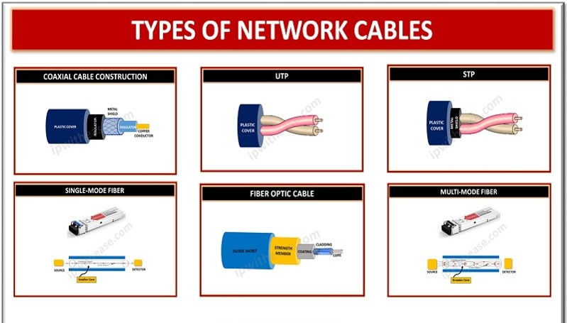

**Wireless Transmission**:

Wi-Fi: Wi-Fi (Wireless Fidelity) enables wireless internet access within a limited range, typically within a home, office, or public hotspot. Wi-Fi uses radio waves to transmit data between devices and a wireless router or access point.

Cellular Networks: Mobile devices connect to the internet through cellular networks, such as 3G, 4G LTE, and 5G. These networks use radio signals to transmit data between mobile devices and cellular towers.

Satellite: In areas where wired or cellular connections are limited, satellite internet provides internet access via communication satellites. Users require a satellite dish and modem to send and receive data.

**Broadband Transmission**:

**Digital Subscriber Line (DSL)**: DSL uses existing telephone lines to provide high-speed internet access. It divides the phone line's bandwidth into separate channels for voice and data transmission.

**Cable Modem**: Cable internet utilizes the same coaxial cable infrastructure used for cable television. It allows for high-speed internet access by sharing the cable network's bandwidth.

**Fiber Optic**: Fiber optic cables transmit data as pulses of light, offering high-speed and reliable internet connections. Fiber optic technology can provide significantly faster speeds compared to traditional copper-based connections.

**Power line Transmission**:

**Power line Communication (PLC)**: **PLC** enables internet connectivity by using electrical power lines as a transmission medium. Adapters are used to convert the data into electrical signals that can travel through the power lines and be received by other adapters in the network.

***Packet switching***

Packet switching is a fundamental process that underlies how the internet works. When data is sent over the internet, it's divided into smaller units called packets. Each packet contains a portion of the original data, along with information like the source and destination addresses.

Instead of sending the entire message in one go, these packets take different routes through the network based on current conditions. This approach offers several benefits: efficient use of network resources, better handling of varying traffic loads, and fault tolerance. If one route is congested or fails, packets can take alternate paths to reach their destination.

Upon arrival at their destination, packets are reassembled in the correct order to reconstruct the original data. This process is managed by routers and switches, which make decisions about how to route each packet based on the most efficient path.

Packet switching allows the internet to handle a large volume of data traffic from multiple sources simultaneously, making it a flexible and scalable way to transmit information across vast distances.

***MODEM***

As part of the **internet infrastructure**, **a modem** plays a crucial role in connecting devices to the internet.

**A modem**, short for **modulator-demodulator**, is a **device** that enables the transmission and reception of data over communication channels. It serves as an interface between a computer or network and the **internet service provider (ISP)**. The modem's primary function is **to convert digital signals** from the computer or network into a format suitable for transmission over the specific communication medium being used, such as telephone lines or cable lines.

Here's a simplified overview of how a modem works:

* **Modulation:** When data is transmitted from a device, such as a computer, the modem modulates the digital signals into analog signals that can be transmitted over the chosen communication medium. Modulation involves altering certain characteristics of the analog signal, such as amplitude, frequency, or phase, to represent the digital information.
* **Transmission**: The modulated analog signals are transmitted over the communication medium, which can be a telephone line, coaxial cable, fiber optic cable, or wireless connection. The specific type of modem and the available infrastructure determine the transmission method.
* **Demodulation**: On the receiving end, another modem is responsible for demodulating the analog signals back into digital data that can be understood by the receiving device, such as a computer or router. Demodulation involves extracting the original digital information from the received analog signals by reversing the modulation process.
* **Data Exchange**: Once the digital data is demodulated, it can be processed by the receiving device and used for various purposes, such as accessing websites, sending emails, downloading files, or streaming content. The modem facilitates the bidirectional flow of data between the device and the ISP, allowing for seamless communication over the internet.

**Modems** come in different types, depending on the type of communication medium used. For example:

* **Dial-up Modem**: These modems were popular in the early days of the internet when users connected to the internet via telephone lines. They converted digital data into audio signals that could be transmitted over a telephone line and then demodulated at the ISP's end.

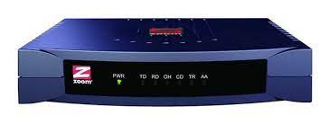

***Dial up modem***

* **Cable Modem**: Cable modems are designed for internet access over cable television infrastructure. They utilize coaxial cables to transmit data signals, allowing for higher data transfer speeds compared to dial-up modems.



***Cable modem***

* **DSL Modem**: **DSL modems** connect to the internet through Digital Subscriber Line (DSL) technology, which uses existing telephone lines. They support simultaneous voice and data transmission by splitting the telephone line's bandwidth into separate channels.

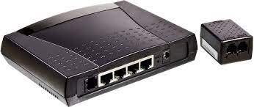

***DSL Modem***

* **Fiber Optic Modem**: Fiber optic modems are used for high-speed internet access over fiber optic networks. They transmit data as pulses of light through thin strands of glass or plastic fibers.

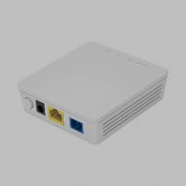

***Fiber optic modem***

***Routers and The Internet***

. Routers play a critical role in the functioning of the internet. They are networking devices that operate at the network layer (Internet Layer) of the TCP/IP protocol suite. Routers are responsible for forwarding data packets between networks, enabling communication and connectivity between devices across the internet.

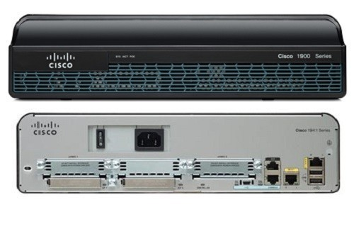

***Router***

Here's how routers work in the context of the internet:

* **Packet Forwarding**: Routers receive data packets from source devices and examine the packet's destination IP address. They use routing tables or forwarding tables to determine the best path for forwarding the packet towards its destination. Routers make decisions based on the destination IP address, subnet masks, and information about neighboring routers.
* **Routing Tables**: Routing tables contain information about the available network paths and the next-hop routers for different IP addresses or network prefixes. Routers use this information to make forwarding decisions. Routing tables are built dynamically through routing protocols, such as OSPF (Open Shortest Path First) or BGP (Border Gateway Protocol), which exchange routing information among routers.
* **Packet Forwarding Decisions**: Once a router determines the next-hop router for a packet, it encapsulates the packet into a new frame compatible with the outgoing interface and forwards it to the appropriate destination. Routers use protocols like ARP (Address Resolution Protocol) to resolve the MAC address of the next-hop router or destination device.
* **Interconnecting Networks**: Routers connect different networks together, allowing devices on one network to communicate with devices on another network. They act as gateways, performing protocol translation and network address translation (NAT) to facilitate communication between devices with different network addresses or protocols.
* **Internet Backbone**: Routers form the backbone infrastructure of the internet. They are interconnected through high-speed links, forming an extensive network that spans the globe. Internet Service Providers (ISPs) and network operators deploy routers to establish the core routing infrastructure, enabling data to traverse across multiple networks to reach its destination.
* **Network Segmentation**: Routers facilitate network segmentation by dividing a large network into smaller subnets. This allows for efficient network management, improved security, and better performance. Routers enforce logical boundaries between subnets, controlling the flow of traffic between them based on routing rules.

Overall, routers are key components in the internet's infrastructure, responsible for directing data packets across networks and enabling global connectivity. They ensure efficient and reliable data transmission by determining the optimal paths for data to travel and forwarding packets to their destinations based on routing protocols and routing tables.

***Introduction to the WEB ( world wide web )***

**The World Wide Web (WWW)** was developed in research laboratories and universities, as a means by which researchers could easily share information about various research efforts. The Web was developed to run on the TCP/IP, the networking protocol of the **internet**, a global network that links computers and users from systems all over the world. However, in contrast to previous internet based services that tended to be purely text based and confusing to novice users, the Web has designed to support richer data types and be easier to use.

***The web as a subset of the internet***

The web, or World Wide Web, is a subset of the internet that specifically deals with the exchange and access of interconnected documents and resources. While the internet encompasses a broader range of services and technologies, the web focuses on the sharing and retrieval of information in the form of web pages.

The web utilizes protocols like HTTP (Hypertext Transfer Protocol) to facilitate communication between web servers and client devices, such as web browsers. Web pages are written in HTML (Hypertext Markup Language) and may include additional technologies like CSS (Cascading Style Sheets) and JavaScript for presentation and interactivity.

The interconnectedness of web pages is made possible through hyperlinks, which allow users to navigate between different web pages and resources. These hyperlinks connect related content and form the web's structure, creating a vast network of interlinked information.

The Web consists of a collection of computers acting as servers that uses the **Hypertext Transfer Protocol, or HTTP**, to serve request for information from programs on end users’ computers, known as browsers because they let a user browse through content. These browsers are designed to interpret and display pages of information written using the **Hypertext Markup Language, or HTML** and other markup languages. These **HTML pages** use both **tags** to affect the appearance of the text on the page (whether onscreen or printed) and to allow graphics and other contents to be embedded in the page.

The programs on the servers that send requests to the browsers are known either as **HTTP** servers or as **listeners**, because they listen for a request to which to respond. The most critical feature of the **HTML** is the ability to embed links to other documents inside a page. These links, when activated by the user, direct the browser to fetch and display a new “page” of information (one or more screens deep). In most **GUI** web browsers, the user simply clicks the linking using her mouse to jump to the new page. These links can direct the browsers to fetch new pages from any **HTTP** server on the Internet anywhere in the world. This allows the user, for example, to retrieve three different pages from three different machines on three different continents – without ever needing to know from where the information is to be accessed, what the time zone is, or what language humans speak there. Some information managers saw the promise of web technology and implemented **HTTP** severs that were accessible only from within their own organization. Such systems have come to be known as intranets, in contrast to the publicly accessible internet. Other organizations have extended their intranet to form an extranet, one or more web applications accessible to a select group of users external to the organization. Often, such applications are used by distributors or current customers to access data that is not truly public but that needs to be available to a wider audience than just a company’s employees. In addition to delivering relatively static documents, the Web can be used as an environment in which to implement functional applications. These applications use **HTML** to display the **GUI**, or graphical user interface, on a remote user’s screen (say, a paralegal large law firm with staff located in different buildings across town) while the computation and processing occur only on the server machine. This process is carried out by programs that are executed by the **HTTP** listener program in response to certain requests from the browser.

It encompasses various sub elements that work together to enable the browsing and interaction with the web content. Here are the key elements of the web

* **Web Pages**: Web pages are the fundamental building blocks of the web. They are documents written in HTML (Hypertext Markup Language), which is a markup language used for structuring and presenting content on the web. Web pages can contain text, images, videos, audio, forms, and other multimedia elements.



***Web pages***

* **Hyperlinks**: Hyperlinks, often referred to as links, are connections between web pages and resources. They are typically displayed as highlighted text or images that, when clicked, allow users to navigate to another web page or access external resources. Hyperlinks enable the interconnectedness of web pages, forming a network of information that users can explore by following links.
* **Web Browsers**: Web browsers are software applications that enable users to access and interact with the web. They interpret HTML, CSS, and other web technologies to render web pages and display them to the user. Popular web browsers include Google Chrome, Mozilla Firefox, Microsoft Edge, Safari, and Opera.

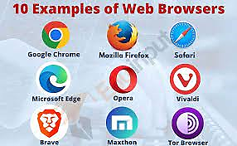

***Web browsers***

* **Web Servers**: Web servers are computers or software applications that store and deliver web pages and resources to client devices. When a user requests a web page by entering a URL (Uniform Resource Locator) in their web browser, the browser sends a request to the appropriate web server. The web server processes the request, retrieves the requested web page and associated resources, and sends them back to the user's browser for display.
* **URLs and Domain Names**: URLs are the addresses used to locate resources on the web. They typically consist of a protocol (such as "http://" or "https://"), a domain name (e.g., "example.com"), and a path that specifies the specific resource or page within the domain. Domain names are human-readable addresses that provide a way to identify websites and web servers. They are associated with unique IP addresses through a system called DNS (Domain Name System).
* **Web Technologies**: The web relies on various technologies to enhance functionality and interactivity. These include:
* **CSS (Cascading Style Sheets)**: CSS is a style sheet language used to describe the presentation and formatting of web pages. It allows developers to control the visual appearance of elements within a web page.
* **JavaScript**: JavaScript is a scripting language that enables dynamic and interactive features on web pages. It allows for client-side scripting, where code is executed on the user's device, enabling tasks such as form validation, animations, and interactivity.
* **Web Standards**: Web standards are guidelines and specifications developed by organizations like the World Wide Web Consortium (W3C) to ensure interoperability and consistency across different web technologies and browsers. Standards such as HTML, CSS, and JavaScript help ensure that web pages are accessible, responsive, and work consistently across various devices and platforms.
* **Web Applications**: Web applications are interactive programs or services accessed through web browsers. They provide functionality and services beyond static web pages. Web applications can range from simple forms and shopping carts to complex platforms like social media sites, online banking systems, and productivity tools. They often utilize server-side scripting, databases, and client-side technologies like JavaScript to deliver dynamic and interactive experiences.

***The TCP/IP***

TCP/IP, which stands for Transmission Control Protocol/Internet Protocol, is a set of networking protocols that form the basis for communication on the internet and many private networks. It is a suite of protocols that enables the exchange of data between devices in a network, allowing reliable and efficient communication.

The TCP/IP protocol suite consists of several protocols that work together to facilitate data transmission. Here are the key protocols within TCP/IP:

**Internet Protocol (IP)**: IP is responsible for the addressing and routing of data packets across a network. It assigns unique IP addresses to devices and breaks data into small packets for transmission.

**Transmission Control Protocol (TCP)**: TCP is a connection-oriented protocol that ensures reliable delivery of data. It breaks data into segments, numbers and sequences them, and provides error-checking mechanisms. TCP establishes a connection between two devices before data exchange and guarantees that data arrives intact and in the correct order.

**User Datagram Protocol (UDP)**: **UDP** is a connectionless protocol that provides a lightweight alternative to **TCP**. It does not establish a connection before transmitting data and does not guarantee reliability or ordering of data. **UDP** is commonly used for real-time streaming, video conferencing, and other applications where speed is more important than reliability.

**Internet Control Message Protocol (ICMP)**: **ICMP** is used for diagnostic and error reporting purposes in **IP networks**. It allows devices to send control messages to indicate network conditions, such as network congestion or unreachable destinations.

**Internet Group Management Protocol (IGMP)**: **IGMP** is used for managing multicast group memberships. It enables devices to join or leave multicast groups to receive or send multicast traffic.

**Internet Protocol Security (IPSec)**: IPSec provides secure communication over **IP** networks through encryption and authentication. It allows for the creation of Virtual Private Networks (**VPNs**) and ensures the confidentiality, integrity, and authenticity of data transmitted over the network.

These protocols work together to establish connections, break data into packets, route packets across networks, reassemble packets at the destination, and provide error checking and recovery mechanisms.

**TCP**/**IP** operates on a layered model, similar to the **OSI** (**Open** **Systems** Interconnection) model. The **TCP**/**IP** model consists of four layers. Each layer performs specific functions and interacts with the corresponding layer on the receiving device to transmit data effectively. ***The layers are:***

***Layers of the TCP/IP model***

* **Network Interface Layer**: This layer corresponds to the physical and data link layers of the **OSI model**. It defines the protocols and hardware necessary for transmitting data over a specific physical medium, such as Ethernet or Wi-Fi. It includes protocols like Ethernet, **ARP (Address Resolution Protocol)**, and **PPP (Point-to-Point Protocol).**
* **Internet Layer**: The Internet Layer is equivalent to the network layer in the **OSI model**. It is responsible for addressing, routing, and fragmenting data packets across different networks. The primary protocol in this layer is the **Internet Protocol (IP)**, which provides logical addressing through IP addresses. Additionally, it includes **ICMP (Internet Control Message Protocol)** for diagnostic and error reporting, and **IGMP** **(Internet Group Management Protocol**) for managing multicast group memberships.
* **Transport Layer**: The Transport Layer is similar to the transport layer of the **OSI model**. It ensures reliable and orderly delivery of data between hosts. The main protocols in this layer are **TCP (Transmission Control Protocol) and UDP (User Datagram Protocol). TCP** provides connection-oriented and reliable data delivery with features like flow control, error recovery, and sequencing. **UDP,** on the other hand, is connectionless and provides a lightweight, unreliable transport option for applications that prioritize speed over reliability.
* **Application Layer**: The Application Layer encompasses protocols and services that directly interact with user applications. It includes protocols such as **HTTP (Hypertext Transfer Protocol)** for web browsing**, FTP (File Transfer Protocol)** for file transfer, **SMTP (Simple Mail Transfer Protocol)** for email, **DNS (Domain Name System)** for domain name resolution, and many more. This layer enables communication between user applications and the underlying **TCP/IP protocols**.

|  |  |
| --- | --- |
| ////////////////  **OSI** | **TCP/IP** |
| Application Layer | Application Layer　 TELNET, FTP, SMTP, POP3, SNMP, NNTP, DNS,NIS, NFS, HTTP, ... |
| Presentation Layer |
| Session Layer |
| Transport Layer | Transport Layer  TCP , UDP , ... |
| Network Layer | Internet Layer   IP , ICMP, ARP, RARP, ... |
| Data Link Layer | Link Layer   FDDI, Ethernet, ISDN, X.25,... |
| Physical Layer |

***TCP/ IP Model***

***The OSI Model***

**The OSI (Open Systems Interconnection) model** is a conceptual framework that standardizes the functions and interactions of network protocols and systems. It provides a structured approach to understanding and designing computer networks. The OSI model is composed of seven layers, each responsible for specific tasks related to data communication. Here's an overview of each layer:

* **Physical Layer**: The physical layer is the lowest layer of the OSI model. It deals with the physical transmission of data over the network medium, including cables, connectors, electrical voltages, and signaling. It defines the characteristics of the physical connection, such as the type of cables and the signaling method used.
* **Data Link Layer**: The data link layer provides error-free transmission of data frames between neighboring network nodes over a shared medium. It breaks the data into frames and adds necessary control information, such as frame synchronization, error detection, and flow control. Ethernet and Wi-Fi are examples of data link layer protocols.
* **Network Layer**: The network layer is responsible for the logical addressing and routing of data packets across different networks. It determines the most efficient path for data transmission and ensures delivery to the correct destination. The Internet Protocol **(IP**) is a key protocol at this layer.
* **Transport Layer**: The transport layer ensures reliable and efficient end-to-end data delivery. It segments data from the upper layers into smaller units, known as segments, and provides mechanisms for error detection, flow control, and retransmission. Transmission Control Protocol **(TCP)** is commonly used at this layer.
* **Session Layer**: The session layer establishes, manages, and terminates communication sessions between applications on different network devices. It provides synchronization points in the data stream to support full-duplex communication and handles session recovery in case of interruptions.
* **Presentation Layer**: The presentation layer is responsible for data representation and ensures that information sent by one system is readable by another. It deals with data formatting, encryption, compression, and conversion between different data formats.
* **Application Layer**: The application layer is the highest layer and provides services directly to end-users. It includes protocols and applications for tasks such as file transfer, email, web browsing, and remote access. Protocols like **HTTP**, **FTP, SMTP**, and **DNS** operate at this layer

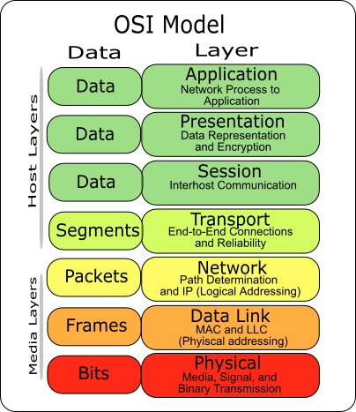

***OSI Model***

***Internet service providers (ISP)***

ISP stands for Internet Service Provider. It refers to a company or organization that provides internet access and related services to individuals, businesses, and other entities. ISPs offer various types of internet connections, such as dial-up, DSL, cable, fiber optic, or satellite, allowing users to connect their devices to the internet.

Examples of well-known local ISPs include **MTN**, **Vodafone**, **AirtelTigo**, **Glo**. ISPs play a critical role in enabling individuals and organizations to access and utilize the internet for communication, information sharing, entertainment, and conducting online business.

***Computer networks***

**Computer networks** refer to **interconnected** systems of computers and other devices that enable communication, data sharing, and resource sharing. These networks facilitate the exchange of information and resources, both within a local environment and across geographically dispersed locations.

Computer networks can be categorized based on their **size, scope**, and **purpose**. Here are some common types of computer networks:

* **Local Area Network (LAN)**: A **LAN** is a network that covers a small area, such as a home, office, or building

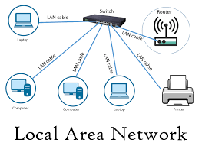

***Local area network***

* + **Metropolitan Area Network (MAN)**: A **MAN** covers a larger area than a LAN but smaller than a WAN, typically encompassing a city or metropolitan area.

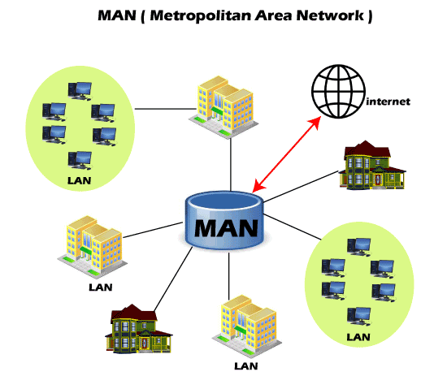

***Metropolitan area network***

* **Campus Area Network (CAN)**: A **CAN** is a network that interconnects buildings within a university campus, corporate campus, or similar environments.

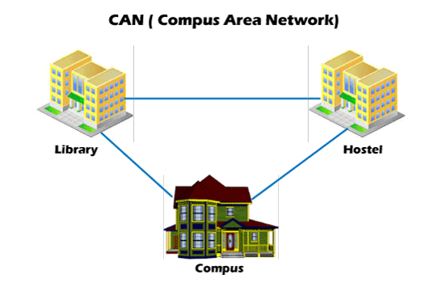

***Campus area network***

* **Personal Area Network (PAN)**: A PAN is a network that connects personal devices in close proximity, typically within a person's workspace or personal environment. Bluetooth and Wi-Fi Direct are common technologies used for PANs, enabling devices like smartphones, laptops, and peripherals to communicate and share data.

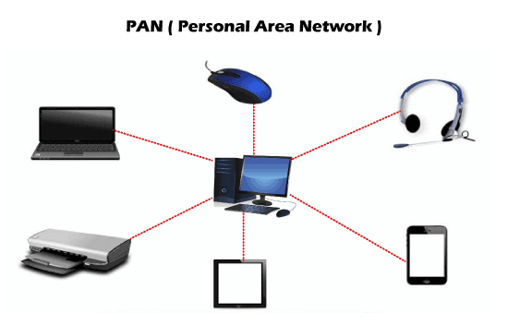

***Personal area network***

* **Wide Area Network** **(WAN)**: A **Wide Area Network (WAN)** is a type of computer network that spans a large geographical area, often covering cities, countries, or even continents. It **connects multiple local area networks (LANs)** or smaller networks together over long distances. In the context of the internet, these LANs can be individual homes, offices, schools, or data centers, each with their own devices and connected systems.

The internet, as a **WAN**, operates using a combination of various technologies, such as fiber-optic cables, satellite links, and wireless connections, to facilitate communication and data exchange between its different components. It relies on a standardized set of protocols, including the **Transmission Control Protocol (TCP)** and the **Internet Protocol (IP)**, to enable data packets to be transmitted and routed across the network.

When you access the **internet**, your device (e.g., computer, smartphone) connects to your **local network (LAN)**, which is typically your home or workplace network. From there, your data is passed through intermediate networks, such as your **Internet Service Provider's (ISP) network**, and eventually travels across multiple routers and switches that make up the **backbone of the internet**. These routers and switches direct the data packets towards their intended destination.

The internet's vastness and complexity come from the fact that it **interconnects millions of networks worldwide**, forming a global communication infrastructure. It doesn't belong to any single entity or organization but rather is a **decentralized and distributed network** that relies on cooperation and peering agreements between various **Internet Service Providers (ISPs)** and network operators.

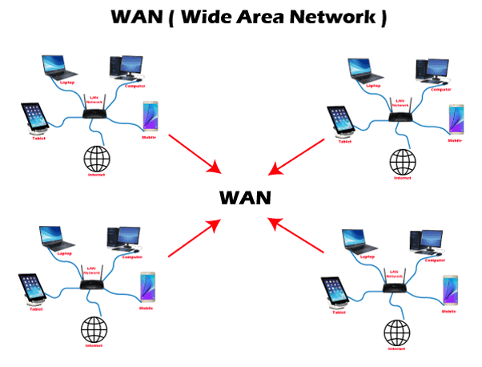

***Wide area network***

* ***Network Topologies***

Network topology refers to the physical or logical arrangement of devices and connections in a computer network. It defines how nodes **(devices)** are interconnected and how data flows within the network. Different network topologies offer varying levels of performance, scalability, and fault tolerance**. Ring topology, star topology, bus topology, tree topology, mesh topology, hybrid topology** are some common network topologies

***Bus topology mesh topology star topology ring topology***

With th**e internet**, it uses a complex and decentralized network topology known as a "network of networks." The internet is not based on a single, uniform topology but rather a combination of various interconnected networks. However, the underlying infrastructure of the internet predominantly relies on a hierarchical and mesh-like structure.

At the highest level, the internet can be seen as a collection of interconnected autonomous systems **(AS)**. Autonomous systems are networks that are under the control of a single organization, such as an internet service provider **(ISP)**, a university, or a large corporation. These autonomous systems connect to each other through Internet Exchange Points **(IXPs)** or private peering arrangements to form the backbone of the internet.

Within each autonomous system, there may be a mixture of different network topologies employed, such as a combination of star, ring, or mesh topologies. These individual networks within autonomous systems can vary in size and configuration based on the specific requirements and infrastructure of the organization.

The internet's overall connectivity is achieved through routers, switches, and other networking devices that help route data packets between networks. These devices use complex routing algorithms to determine the best path for data transmission based on factors such as network congestion, latency, and cost.

The decentralized nature of the internet allows for redundancy and fault tolerance. If one path or network becomes unavailable, data can be rerouted through alternative paths. This resilience helps ensure that the internet remains operational even in the event of disruptions or failures in specific parts of the network.

**In summary,** the internet is a vast network of interconnected devices and networks that allows for the transfer of information across the globe. Here is a simplified explanation of how the internet works:

* **Devices and Connections:** The internet connects various devices such as computers, servers, routers, and mobile devices. These devices are connected through wired or wireless connections, including Ethernet cables, fiber-optic cables, or wireless networks.
* **Protocols**: The internet relies on a set of protocols, or rules, to govern the exchange of data. The most fundamental protocol is the Internet Protocol (IP), which provides a unique address to each device on the internet, known as an IP address.
* **Data Packaging**: When you send or receive information over the internet, it is broken down into small data packets. Each packet contains a portion of the data, along with the source and destination IP addresses.
* **Routing**: Data packets travel through a series of interconnected routers that make up the internet infrastructure. Routers are specialized devices that forward packets based on the destination IP address. They determine the most efficient path for the data to reach its destination.
* **Transmission**: Data packets are transmitted across the internet using various transmission technologies, such as Ethernet, fiber optics, or wireless signals. The packets may traverse multiple networks owned by different ISPs (Internet Service Providers) before reaching their destination.
* **Internet Service Providers (ISPs):** ISPs are companies that provide access to the internet. They maintain the physical infrastructure and network connections necessary to connect users to the internet. ISPs may offer different types of connections, such as DSL, cable, fiber optics, or satellite.
* **Domain Name System (DNS)**: When you enter a website address (URL) in your web browser, the DNS translates the human-readable domain name (e.g., [www.example.com](http://www.example.com)) into the corresponding IP address. This allows your device to locate the correct server on the internet.
* **Servers and Hosting**: Websites, emails, and other online services are hosted on servers. Servers are powerful computers that store and process data, and they communicate with clients (user devices) to deliver web pages, files, or other requested content.
* **Request and Response**: When you request a webpage or any online content, your device sends a request to the appropriate server. The server processes the request, retrieves the requested data, and sends it back to your device in the form of data packets.
* **Data Reassembly**: Once the data packets reach their destination (your device), they are reassembled in the correct order to reconstruct the original information. This process occurs at the transport layer of the network protocol stack, typically using protocols like TCP (Transmission Control Protocol).
* **Displaying the Content**: Finally, your device's web browser or application renders the received data packets into a readable format, displaying the webpage, images, videos, or other content.

This simplified overview illustrates the basic principles of how the internet works. In reality, the internet is a complex network infrastructure with many interconnected systems, protocols, and technologies working together to enable global communication and data exchange, typically is how it is vividly and broadly explained above.

***Project Limitations***

Due to the complexity of the topic, the project will provide a simplified overview of certain aspects. It will not cover specialized areas like deep packet inspection, advanced cryptography, or specific programming details of networking protocols.

***Academic and Practical Relevance of the Project***

***Academic Relevance****:* Understanding how the internet works is becoming increasingly important in various academic disciplines. This project contributes to academic relevance by offering a foundational understanding of networking principles, which can serve as a basis for more advanced studies in computer science, information technology, engineering, and related fields. Students who grasp the fundamentals of the internet's functioning will be better prepared to explore more complex topics such as network security, cloud computing, and internet of things (IoT) technologies.

Moreover, the project aligns with educational objectives by providing a clear and concise explanation of intricate technical concepts. It enhances the learning experience by breaking down complex ideas into digestible units, making it easier for students to engage with and retain the material. As the internet continues to evolve, this knowledge will empower students to keep up with the latest technological developments.

***Practical Relevance****:* In the practical realm, the knowledge gained from this project holds substantial value. The internet has become an integral part of everyday life, impacting communication, commerce, entertainment, and more. A strong grasp of how the internet works translates into practical skills that benefit individuals in multiple ways:

* **Enhanced Digital Literacy:** Understanding the basics of internet infrastructure, data transmission, and protocols fosters better digital literacy. Users can navigate online platforms more effectively, discern reliable sources, and assess online security risks.
* **Informed Decision-Making:** Knowledge of the internet's mechanisms empowers individuals to make informed decisions about their online activities. This includes choosing secure communication methods, understanding privacy settings, and recognizing potential threats.
* **Career Advancement:** Proficiency in networking concepts is valuable in various professional roles. Individuals pursuing careers in IT, cybersecurity, web development, and telecommunications will find this knowledge essential for their job roles.
* **Entrepreneurship:** Small business owners can leverage their understanding of the internet to optimize their online presence, enhance e-commerce strategies, and implement better cybersecurity practices.
* **Personal Security:** The project equips users with the ability to recognize common online threats and implement basic security measures. This leads to safer online interactions and protection against cyberattacks.
* **Effective Communication:** Knowing how data is transmitted over the internet aids in comprehending the intricacies of online communication, enabling more effective use of communication tools, social media, and collaboration platforms.

***Project Activity Planning and Schedules***

**Month 1:**

1. **Week 1:** Research and Topic Selection
   * Identify key topics and concepts for the project.
   * Gather initial reference materials and resources.
2. **Week 2-3:** Content Development and Organization
   * Create a detailed outline for the project's content.
   * Write the content for each section, explaining concepts clearly.
3. **Week 4:** Visual Aids and Diagrams
   * Design simple diagrams and visual aids to enhance explanations.

**Month 2:**

4. **Week 1-2:** Review and Feedback Incorporation

* Review and revise the content for accuracy, clarity, and coherence.
* Share the project with peers or mentors for feedback.

1. **Week 3-4:** Formatting and Finalization
   * Format the content consistently and professionally.
   * Proofread for grammar, spelling, and formatting errors.
2. **Week 4:** Presentation Preparation
   * Prepare a concise project overview or presentation.

**Month 3:**

7. **Week 1:** Submission and Publishing

* Submit the final project according to submission guidelines.
* If applicable, publish the project on relevant platforms.

1. **Week 2:** Promotion and Sharing
   * Promote the project through social media, forums, or educational platforms.
   * Engage with users who interact with the project.
2. **Week 3:** Reflection and Future Planning
   * Reflect on the project's successes and areas for improvement.
   * Consider feedback and plan for potential updates or expansions.

***Beneficiaries of the Project*:**

* **Students:** Students across various academic levels and disciplines stand to gain significantly from this project. It aids their studies by providing a clear foundation in networking concepts, which can be applied in coursework and future research endeavors.
* **General Users:** Everyday internet users who wish to gain a deeper understanding of their online activities and interactions will benefit from the project. They will be better equipped to navigate digital platforms safely and make informed choices online.
* **Small Business Owners:** Entrepreneurs and small business owners can use the knowledge gained to optimize their online presence, streamline their digital marketing strategies, and implement security measures to protect their data and customer information.
* **Educators:** Teachers and educators can incorporate the project's resources into their curriculum to enhance students' understanding of the internet's functionality. The simplified explanations and visual aids make it an ideal teaching tool.
* **Professionals:** Individuals in the fields of IT, computer science, cybersecurity, and related industries can use the project as a refresher or reference to reinforce their understanding of networking principles.

***Recommendations for Future Works*:**

* **Incorporate Emerging Technologies:** As technology evolves, consider updating your project to include information about emerging technologies such as 5G, edge computing, IoT, and AI in networking. Exploring how these technologies interact with the fundamental principles of the internet can provide valuable insights.
* **Advanced Security Topics:** Expand your project to cover advanced security topics such as penetration testing, intrusion detection systems, and encryption algorithms. These areas are crucial for understanding modern cybersecurity challenges.
* **Case Studies:** Include real-world case studies that demonstrate how the concepts you've explained in your project apply to practical scenarios. Case studies can provide concrete examples of how the internet works in various contexts.
* **Interactive Elements:** Create interactive elements like quizzes, simulations, or interactive diagrams that allow users to engage with the content and test their understanding. These elements can enhance the learning experience.
* **Global Internet Governance:** Consider discussing the international organizations and governance structures that oversee aspects of the internet, such as ICANN (Internet Corporation for Assigned Names and Numbers) and regional internet registries.

***Recommendations for Project Commercialization*:**

* **Online Courses:** Develop a comprehensive online course based on your project's content. This could include video lectures, quizzes, assignments, and a certification upon completion. Platforms like Udemy, Coursera, or your own website could host the course.
* **Ebooks and Printed Guides:** Compile your project into an ebook or a printed guide that users can purchase. Offer additional resources, exercises, and practical tips to enhance the value of the guide.
* **Workshops and Webinars:** Host workshops or webinars to teach individuals, students, or businesses about the basics of how the internet works. These events can be conducted online or in-person, depending on your reach.
* **Collaboration with Educational Institutions:** Partner with schools, colleges, and universities to integrate your project into their curriculum. Offer workshops or resources to educators to facilitate teaching networking concepts.
* **Consulting Services:** Offer consulting services to businesses looking to understand their network infrastructure better. You could provide insights on optimizing network performance, security, and scalability.
* **Mobile Apps:** Create a mobile app that delivers bite-sized lessons and quizzes on internet fundamentals. This approach can cater to users who prefer learning on their mobile devices.
* **Partnerships with Tech Companies:** Collaborate with technology companies that offer networking products or services. Your project's educational content could be promoted as a resource for their customers.
* **Professional Development Programs:** Work with professional development organizations to offer your project as a resource for professionals looking to upskill in networking concepts.

***References***

Apparently, most reference towards this project were made from our field of studies and lectures we have attained from our course as students in **Information Technology** in our noble university **(KNUST)**, we have thoroughly covered most of areas concerning the internet and its connectivity. Some areas include: **web based concept, fundamentals of information technology, computer network fundamentals and some programming languages**

Below are some other external sources which aided us in our project establishment. Some key references include:

• ***Academic Databases*:**

Search IEEE Xplore (<https://ieeexplore.ieee.org/>) and ACM Digital Library (<https://dl.acm.org/>) using relevant keywords to find scholarly articles and research papers.

• ***Online Learning Platforms:***

Platforms like Coursera (<https://www.coursera.org/>), edX (<https://www.edx.org/>), and Udemy (<https://www.udemy.com/>) offer online courses related to networking and computer science.